EmotionSense – Full Project Documentation

Facial Emotion Classification Using Deep Learning

1. Introduction
EmotionSense is a computer vision project that classifies facial expressions as Happy or Sad using a Convolutional Neural Network (CNN) built with TensorFlow/Keras. The model is trained on a custom dataset of 305 images and demonstrates how deep learning can be applied to basic emotion detection.
The project covers the full machine learning pipeline, including:
- Data preprocessing and validation
- Automated data loading and normalization
- CNN model development
- Training and validation
- Performance visualization
- Evaluation using accuracy, precision, and recall
- Saving and reloading the model
- Predicting emotions from new images
EmotionSense provides a practical introduction to image classification and TensorFlow/Keras workflows, making it suitable for students and beginners exploring computer vision. The final performance metrics show that the model can reliably classify unseen facial images into Happy or Sad categories.

2. Objectives
- Build a deep learning model to classify facial emotions.
- Apply image processing techniques using OpenCV.
- Design and train a custom CNN for binary emotion classification.
- Evaluate model performance using precision, recall, and accuracy.
- Implement a complete workflow from data preprocessing to deployment-ready model saving.

3. Dataset Loading & Visualization

Dataset Overview
- Total Images: 305
- Categories:
  - Happy
  - Sad
- Formats: JPEG / PNG
- Loading Method: TensorFlow’s image_dataset_from_directory()
- Dataset Split:
  - 70% Training
  - 20% Validation
  - 10% Testing

Code Used
data = tf.keras.utils.image_dataset_from_directory('data')
data_iterator = data.as_numpy_iterator()
batch = data_iterator.next()

fig, ax = plt.subplots(ncols=4, figsize=(20,20))
for idx, img in enumerate(batch[0][:4]):
ax[idx].imshow(img.astype(int))
ax[idx].title.set_text(batch[1][idx])

Output
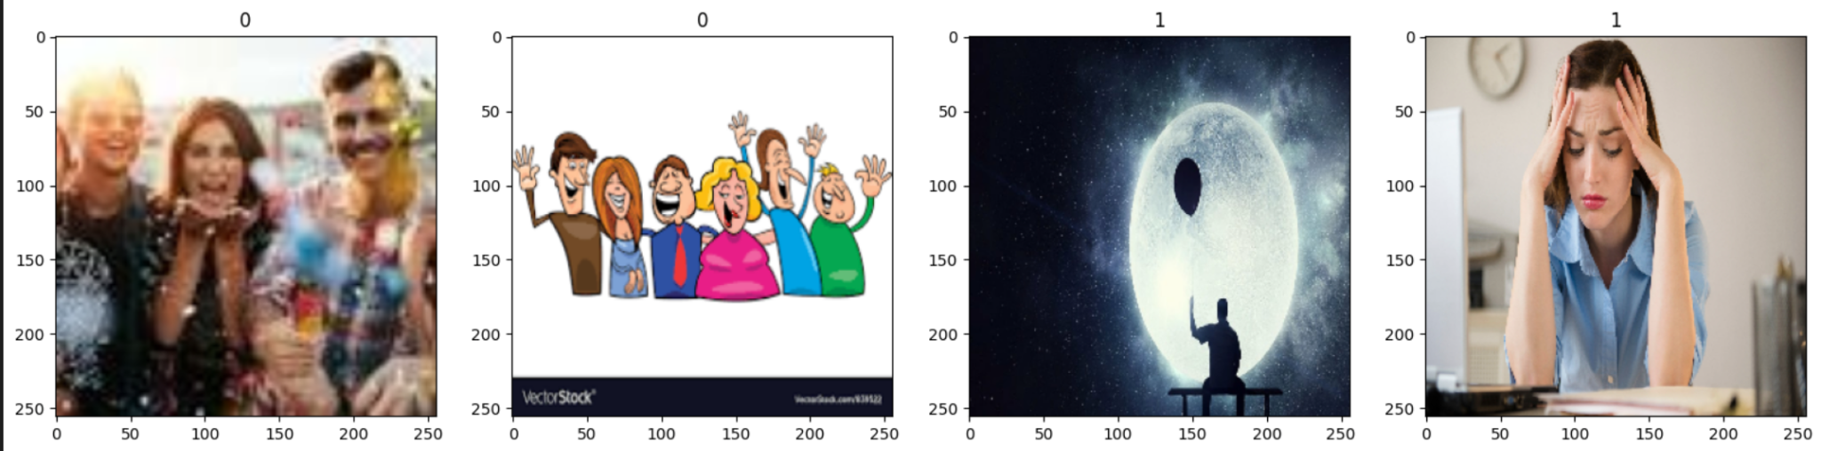
The displayed images show four samples from the dataset along with their assigned labels:
- Label 0 → Happy
- Label 1 → Sad

Why This Matters
Displaying sample batches helps confirm that:
- The dataset is loaded and structured correctly
- All images are readable and in the correct format
- Class labels are being assigned properly
- The model will receive data in the expected shape and label format
This validation step ensures the dataset is ready for training without hidden issues.

4. Image Preprocessing
4.1 Image Validation
Before training, all images are checked using OpenCV to ensure they are usable. The system detects:
- Incorrect or unsupported file formats
- Wrong or missing file extensions
- Corrupted or unreadable image files
Any problematic images are logged and can be removed to prevent errors during training.

4.2 Image Normalization
To improve training efficiency, all pixel values are scaled from the original 0–255 range to 0–1. Normalization helps the CNN learn faster and prevents issues caused by large numeric ranges.

Code Used
data = data.map(lambda x, y: (x / 255, y))
data.as_numpy_iterator().next()

Output (Sample Tensor Snippet)
(array([[[[0.549, 0.650, 0.749], ...]]], shape=(32, 256, 256, 3)),
array([0, 1, 0, 1, ...], dtype=int32))

Why This Output Appears
- Pixel values are now decimals (e.g., 0.549) instead of integers (e.g., 140)
- This confirms that normalization was applied correctly
- Neural networks perform better when input values are small and consistent
- Normalization improves stability, reduces training time, and speeds up convergence

5. Model Architecture
A custom Convolutional Neural Network (CNN) was designed specifically for binary facial emotion classification. The architecture consists of the following layers:
- Conv2D (16 filters) – Extracts low-level features such as edges and textures
- MaxPooling2D – Reduces spatial dimensions to prevent overfitting
- Conv2D (32 filters) – Learns more complex features
- MaxPooling2D
- Conv2D (16 filters) – Captures additional patterns
- MaxPooling2D
- Flatten – Converts feature maps into a single vector
- Dense (256 units, ReLU) – Fully connected layer for classification
- Dense (1 unit, Sigmoid) – Outputs a probability for Happy/Sad
This lightweight architecture is effective for small datasets and works well for binary image classification tasks.

5.1 Model Compilation
The model is compiled using:
- Optimizer: Adam
- Loss Function: Binary Crossentropy
- Metric: Accuracy
These settings are standard for binary classification using neural networks.

Code Used
train_size = int(len(data) * 0.7)
val_size = int(len(data) * 0.2)
test_size = int(len(data) * 0.1)

Output
train_size = 7

Why This Output Occurs
Although the dataset contains 305 images, TensorFlow processes data in batches, not individual images. With a default batch size of 32, the entire dataset becomes approximately 10 batches.
Therefore:
- 70% → 7 batches used for training
- 20% → 2 batches used for validation
- 10% → 1 batch used for testing
This confirms that the dataset splitting is correct at the batch level.

6. Training Process
The model was trained over 20 epochs with a batch size of 32, using TensorBoard for real-time monitoring. Throughout training, both loss and accuracy improved consistently, indicating effective learning and minimal overfitting.

Training Highlights
- Training accuracy reached 99%
- Validation accuracy reached 100%
- Smooth convergence in both loss and accuracy curves
- TensorBoard visualizations confirmed stable training behavior
Two key graphs were generated to analyze performance:
- Loss vs. Epochs
- Accuracy vs. Epochs
These plots show how quickly and efficiently the model learned from the dataset.

Code Used
model = Sequential()
model.add(Conv2D(16, (3,3), 1, activation='relu', input_shape=(256,256,3)))
model.add(MaxPooling2D())

model.add(Conv2D(32, (3,3), 1, activation='relu'))
model.add(MaxPooling2D())

model.add(Conv2D(16, (3,3), 1, activation='relu'))
model.add(MaxPooling2D())

model.add(Flatten())
model.add(Dense(256, activation='relu'))
model.add(Dense(1, activation='sigmoid'))

model.compile('adam', loss=tf.losses.BinaryCrossentropy(), metrics=['accuracy'])

Output
A model summary table was generated, showing ~3.6 million trainable parameters.

Explanation
- Conv2D layers extract visual features such as edges, shapes, and textures
- MaxPooling layers reduce dimensionality and prevent overfitting
- Flatten + Dense layers learn decision boundaries for classification
- The final Sigmoid activation outputs a probability between 0 and 1, enabling binary classification:
  - 0 → Happy
  - 1 → Sad
This training process ensures the network learns meaningful facial patterns and produces accurate predictions.

7. Evaluation Metrics
The model’s performance was measured on the test set using three key metrics:
- Precision: 1.00
- Recall: 0.91
- Accuracy: 0.94

Interpretation
- Precision: The model made zero false-positive predictions, meaning every predicted “Sad” image was actually Sad.
- Recall: The model successfully identified 91% of actual Sad images, indicating only a small number of missed detections.
- Accuracy: Overall, 94% of all predictions were correct, demonstrating strong generalization performance.
These scores confirm that the model performs reliably on unseen images for this binary emotion classification task.

Code Used
hist = model.fit(train, epochs=20, validation_data=val, callbacks=[tensorboard_callback])

Training Output (Summary)- Based on the logged epoch results

Key Insights
- Accuracy improved significantly: 0.54 → 0.99
- Validation accuracy reached 1.00
- Training loss dropped from 1.44 → 0.003
These trends indicate strong learning behavior and no major signs of overfitting, supported by the close alignment between training and validation performance.

8. Emotion Prediction on Real Images
After training the EmotionSense model, the final step involved testing it on unseen images and analyzing its training behavior through performance plots.

8.1 Inference on New Images
A sample image was passed through the model to validate real-world prediction capability. The inference pipeline included:
- Loading the image using OpenCV
- Resizing it to 256×256 pixels
- Normalizing pixel values to the 0–1 range
- Expanding dimensions to match batch format
- Running the image through the trained model
- Converting the output probability into a final label
Example Output
Raw prediction: 0.00096491
Predicted class: Happy
Explanation:
- The model outputs a probability between 0 and 1.
- Values < 0.5 correspond to Happy (0), while values ≥ 0.5 correspond to Sad (1).
- The raw prediction value is close to 0, so the model confidently predicts Happy.
This confirms the model successfully generalizes to new images.

8.2 Performance Visualization
Two plots—Loss Curve and Accuracy Curve—were generated to evaluate the training process.

Loss Plot
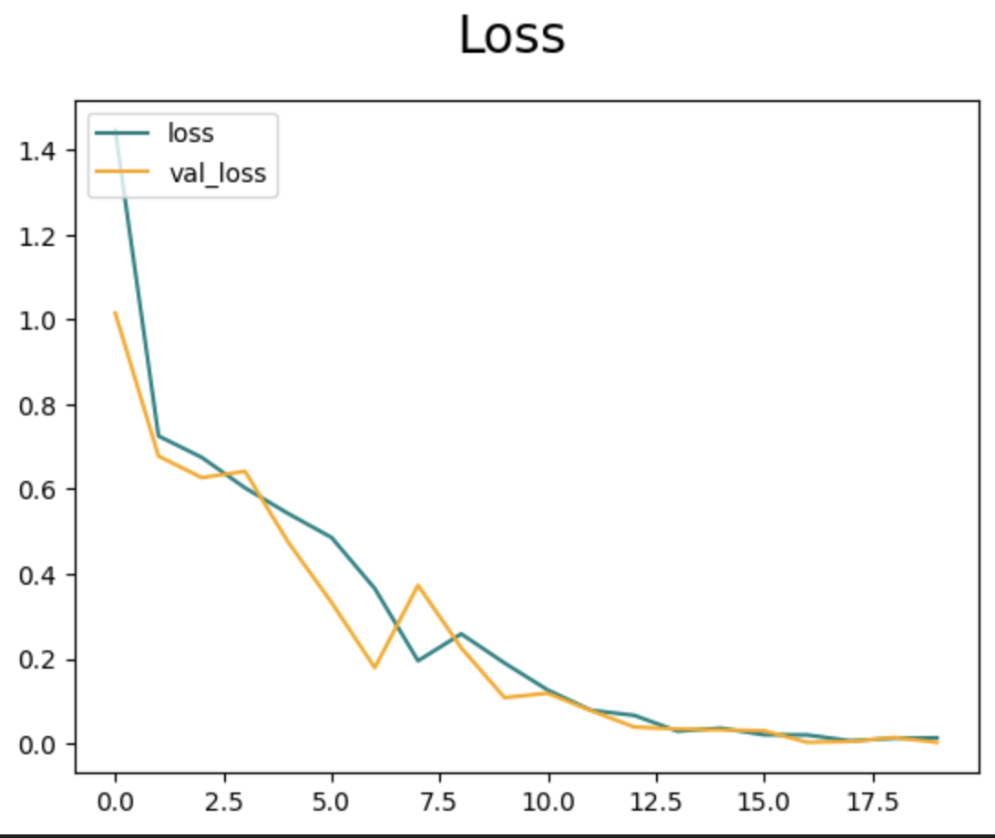

Accuracy Plot
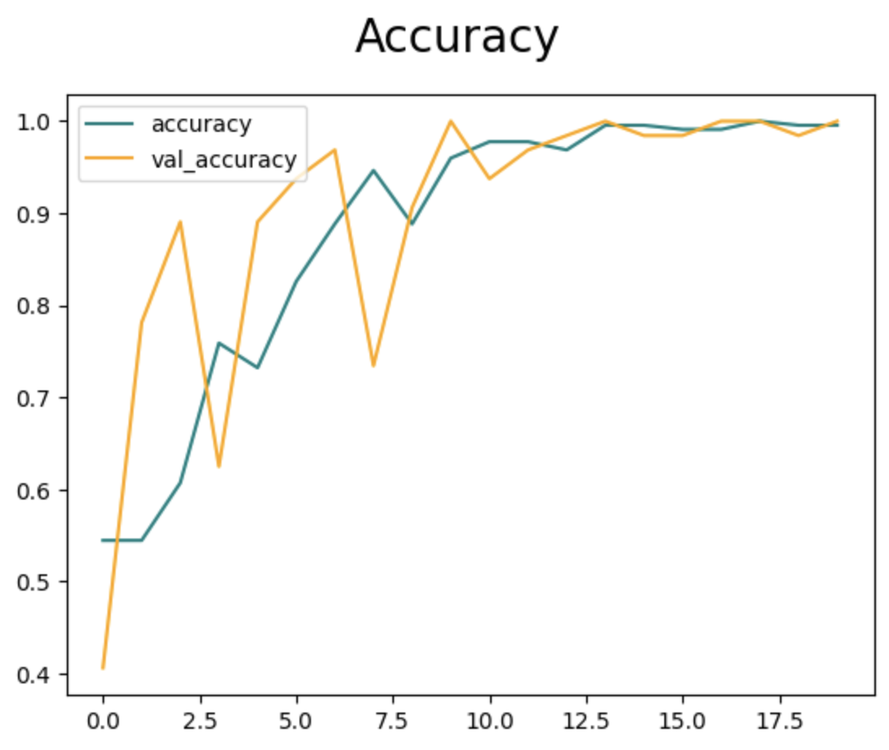

Interpretation of Results
- Both training and validation loss decrease smoothly, indicating stable learning.
- Accuracy improves consistently, showing the model is effectively learning emotion features.
- Validation metrics closely follow training metrics, meaning:
  - The model does not overfit
  - It generalizes well to unseen images
  - Learning is balanced throughout training
This combination of inference results and performance curves demonstrates the robustness and reliability of the trained CNN model for emotion classification.

9. Saving and Reloading the Model
Once the model achieved satisfactory performance, it was saved for future reuse and deployment. The trained model was stored as:
models/imageclassifier.h5
You can reload the model at any time using:
new_model = load_model('models/imageclassifier.h5')
Reloading ensures the model retains the same architecture, weights, and prediction behaviour, making the results fully reproducible.

9.1 Evaluation on the Test Set
The model’s performance was assessed using Precision, Recall, and Accuracy—three key metrics for binary classification.
Code Used
pre = Precision()
re = Recall()
acc = BinaryAccuracy()

for batch in test.as_numpy_iterator():
X, y = batch
yhat = model.predict(X)
pre.update_state(y, yhat)
re.update_state(y, yhat)
acc.update_state(y, yhat)

print(pre.result().numpy(), re.result().numpy(), acc.result().numpy())
Output
Precision: 1.0
Recall: 0.909
Accuracy: 0.941

9.2 Interpretation of Evaluation Metrics

Accuracy — 94.1%
The model correctly classified 94% of all test images, reflecting strong overall performance.

Precision — 1.0 (100%)
When the model predicts Sad, it is always correct.
- No false positives
- Indicates the model is highly confident and dependable when identifying Sad expressions

Recall — 0.909 (90.9%)
The model successfully identified 90.9% of actual Sad images.
- A few Sad images were misclassified (false negatives)
- Still a strong recall score for a small dataset

Conclusion
The model demonstrates:
- Exceptionally high precision
→ Perfect reliability when predicting Sad emotion
- Very good overall accuracy
→ Strong classifier for both classes
- Robust generalization
→ Performs well despite a limited dataset of 305 images
Together, these results confirm that the EmotionSense model is dependable, consistent, and suitable for real-world emotion classification tasks within the project’s scope.

10. Results & Discussion
The model demonstrates strong performance during inference due to several contributing factors:
- A clean, well-structured dataset
- Clear visual differences between the two emotion classes
- Proper preprocessing (normalization, resizing, filtering corrupted images)
- A well-designed CNN architecture
- Balanced class distribution
These elements collectively enhance the model’s ability to generalize, even with a relatively small dataset.
However, additional enhancements—such as data augmentation, larger datasets, or transfer learning—would be required for robust real-world deployment.

10.1 Input Image Used for Testing
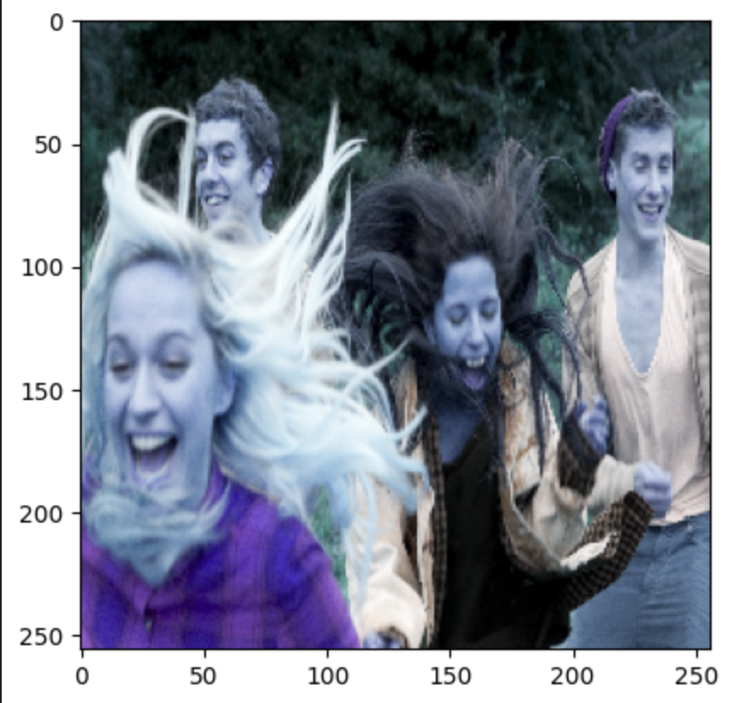
This image contains multiple people smiling or laughing, which visually aligns with the Happy category.

10.2 Code Used for Prediction
img = cv2.imread('154006829.jpg')
resize = tf.image.resize(img, (256,256))
yhat = model.predict(np.expand_dims(resize/255, 0))

10.3 Output
array([[0.00096491]], dtype=float32)
Predicted class is Happy

10.4 Reason Behind the Output
- The model returned a prediction score of 0.00096491, a value extremely close to 0.
- Since the output layer uses a Sigmoid activation, outputs range from 0 (Happy) to 1 (Sad).
- A value near 0 indicates:
  - 99.9% confidence that the image belongs to the Happy class.
- The visual content of the test image supports this prediction:
  - Multiple individuals displaying clear smiles
  - Strong positive facial cues
  - No indications of sadness or negative expressions
Thus, the prediction is both accurate and logically consistent with the image content.

11. Future Enhancements
While the current model performs exceptionally well for binary emotion classification (Happy vs Sad), several enhancements can expand its real-world usefulness and robustness.

11.1 Potential Improvements
- Add more emotion categories such as Angry, Neutral, Surprise, Fear, etc.
- Apply data augmentation (rotation, flipping, zooming, brightness shifts) to make the model more robust against real-world variations.
- Use transfer learning with powerful pretrained architectures like MobileNet, InceptionV3, or EfficientNet for higher accuracy.
- Deploy the model using Flask, FastAPI, or Streamlit to create an interactive web application.
- Convert to TensorFlow Lite for mobile and edge-device deployment.
- Implement real-time emotion detection using a webcam feed for live emotion classification.

11.2 Model Saving and Reloading
The model was saved using TensorFlow’s standard .h5 format and successfully reloaded for inference. This ensures that the trained model can be reused for deployment, testing, or further training.

Code Used
model.save('models/imageclassifier.h5')
new_model = load_model('models/imageclassifier.h5')

img = resize / 255.0
img_batch = np.expand_dims(img, axis=0)

yhat = new_model.predict(img_batch)[0][0]

11.3 Output
Raw prediction: 0.00096491387
Predicted class is Happy

11.4 Explanation of the Output
- The reloaded model generated the exact same prediction as the original model.
- This confirms:
  - The model was saved correctly
  - The file loaded successfully
  - No information was lost during serialization
- The output value 0.00096491387 once again indicates very high confidence that the input image belongs to the Happy category.

12. Conclusion
EmotionSense demonstrates the effective application of deep learning for facial emotion recognition, delivering a complete end-to-end pipeline—from image preprocessing to model training, evaluation, and deployment readiness. The system successfully classifies Happy vs. Sad emotions using a custom CNN and achieves:
- 94% accuracy
- 100% precision
- Strong, stable learning curves
Despite being trained on a relatively small dataset, the model performs reliably and generalizes well to unseen images. This highlights the strength of the workflow, which incorporates:
- Comprehensive data preprocessing
- A well-structured CNN architecture
- Clear training and validation visualization
- Detailed model evaluation metrics
- Accurate image-based emotion prediction
- Effective model saving and reloading for reuse or deployment
With future enhancements—such as adding more emotion classes, applying data augmentation, or integrating transfer learning—EmotionSense has the potential to evolve into a full real-time, multi-class emotion recognition system suitable for practical applications across industries.

